**ST.XAVIER,S COLLEGE**

**Maitighar, Kathmandu**



Digital Logic Lab Assignment #8

**To perform reflection operation**

Yub Raj Basnet

013BScCSIT048 (4th Semester)

**Submitted to**

|  |  |
| --- | --- |
| Er. Anil Sah  (Lecturer, St.Xavier’s College ) |  |

**Source Code**

//---------------------------------------------------------------------------

#include <vcl\vcl.h>

#pragma hdrstop

#include "Unit1.h"

//---------------------------------------------------------------------------

#pragma resource "*.dfm"

TForm1 *Form1;

//---------------------------------------------------------------------------

__fastcall TForm1::TForm1(TComponent* Owner)

: TForm(Owner)

{

}

//---------------------------------------------------------------------------

void __fastcall TForm1::Button1Click(TObject *Sender)

{

int x,y,i,j;

x=Image1->Height;

y=Image1->Width;

for(int i=0;i<=x;i++)

for(int j=0;j<=y;j++)

Image2->Canvas->Pixels[x-i][j]=Image1->Canvas->Pixels[i][j];

Image4->Canvas->Pixels[x-i][j]=Image3->Canvas->Pixels[i][j];

}

//---------------------------------------------------------------------------

void __fastcall TForm1::Button2Click(TObject *Sender)

{

int x,y,i,j;

x=Image1->Height;

y=Image1->Width;

for(int i=0;i<=x;i++)

for(int j=0;j<=y;j++)

{

Image3->Canvas->Pixels[i][y-j]=Image1->Canvas->Pixels[i][j];

Image4->Canvas->Pixels[i][y-j]=Image2->Canvas->Pixels[i][j];

}

}

# Output

With x-axis:

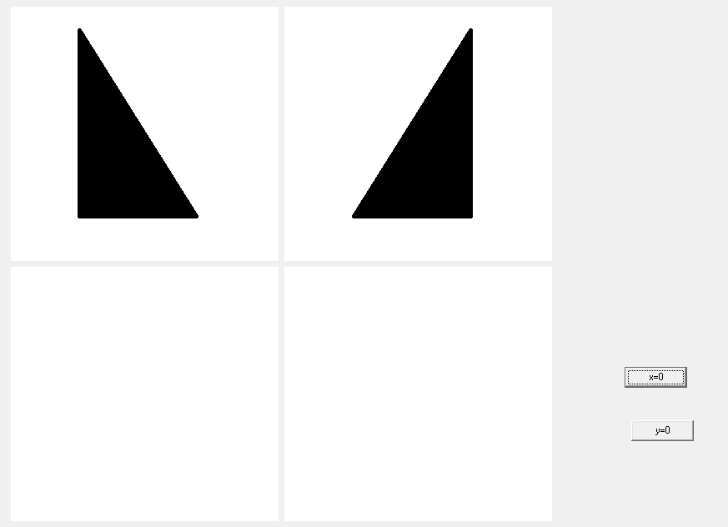

With y-axis

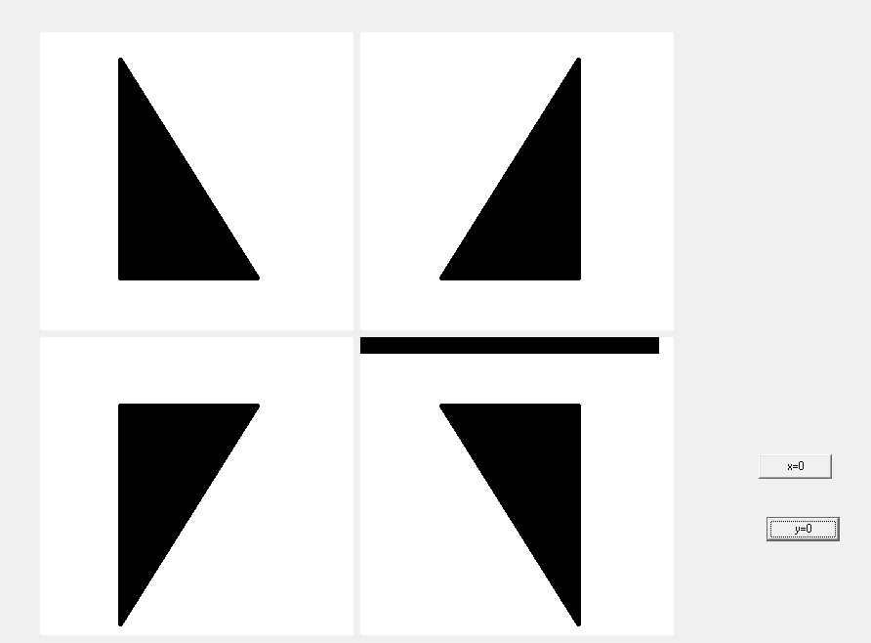

# Conclusion:

Hence, the reflection was done using C++ builder.

# Reference

[1] Er.Anil Sah,”CG Manual( 2015 ).pdf”